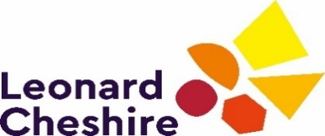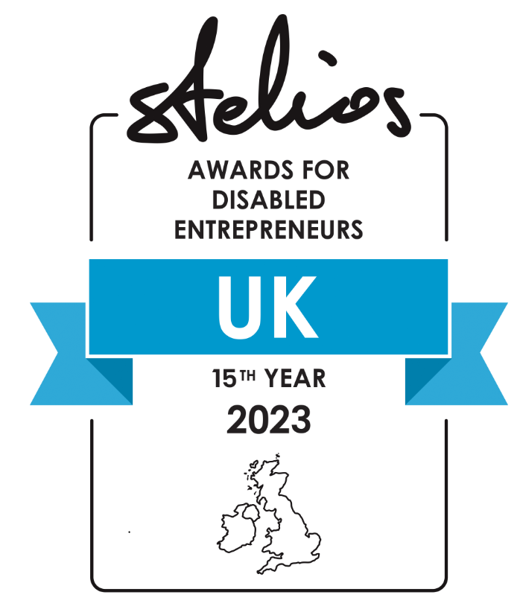

Stelios Awards for Disabled Entrepreneurs in the UK 2023
Application Form

The Awards offer one of the largest financial prizes for disabled entrepreneurs in the UK. A top prize of £50,000, and two finalist prizes of £30,000 and £20,000 are up for grabs for this year’s winners, offering £100,000 in cash in total for 2023.
Applications open from Monday 27 February 2023. Deadline to apply, not later than Friday 14 April 2023 at 17:00. All applications must be completed in full and emailed to Tracy.Ghori@stelios.com
Please refer to the Awards criteria and terms and conditions available at www.leonardcheshire.org/Stelios. For awards enquiries, please email SteliosAward@leonardcheshire.org

Applicant’s Personal Details

- First name:
- Last name:
- Date of birth:

- Do you have a disability as defined by the Equality Act 2010?
Yes/No (please delete as appropriate)

- Have you applied to the Stelios Awards before?
Yes/No (please delete as appropriate)

- If yes, please list the years you have applied and the name of the business(es):

Click or tap here to enter text.

Applicant’s Business Details

- In one sentence please explain what your business is:

Click or tap here to enter text.

- Business name:
- Business address:
- Phone number:
- Mobile number:
- Email address:
- Website:
- Registered UK Company number:
- Do you own at least 50% of the company? Yes/No (please delete as appropriate)
and state the %
- Business bank account details: IBAN

About the Applicant’s Business

- In no more than 200 words please tell us about your business in more detail. Discuss your products, if any, in what markets you operate, who your customers are, who you compete with, how it fills a need in the market, why you are passionate about it and any other details you feel are relevant.

Click or tap here to enter text.

- Please tell us how your disability has impacted your business. For example, you could tell us if your disability inspired your decision to start a business or influenced you to target a specific customer base. Or you might choose to tell us some of the barriers you had to overcome to get your business off the ground.

Click or tap here to enter text.

- If you won an award how would you invest the prize money?

Click or tap here to enter text.

- Please tell us about any Press/Media you may have had, negative or positive. You may provide links if any. Please note failure to disclose negative press could exclude you from the awards.

Click or tap here to enter text.

e) Please list all your active Social Media accounts across all platforms (Facebook, Twitter, Instagram etc).

Click or tap here to enter text.

- Financial Information

Financial year | 2021 | 2022 | 2023 (forecast)
Turnover £
Net profit or loss
Number of staff
Number of customers served per year

Declaration

I confirm that I have read and accept the full Terms and Conditions of the Stelios Awards for Disabled Entrepreneurs in the UK 2023. I understand that all judging decisions by Sir Stelios are final.

I certify that the facts above are correct. I understand that Leonard Cheshire and the Stelios Philanthropic Foundation will process the personal and special information that I have provided on this form and in attachments for the promotion of the Awards in line with both organisations’ privacy policies available at:
www.leonardcheshire.org/privacy-notice
www.stelios.org/footer/privacy-policy.html

- Please sign and date below once you have read the above confirmation. If submitting electronically, please type your name in the box below.

Signature
Position
Date

End of form

